# Setting Up your Funnel and Onlyfans

* First, a principle: Your funnel should be as short as possible and have only one direction to go.
* Keep this in mind, that’s the entire way we build this.
* You will spend 13$/month to set up a great funnel and we’ll show the steps how to do that.
* **Step 1 - Setting up Getallmylinks:**
  + Setup an account on <https://getallmylinks.com/>
  + Register with your email address and password
  + Verify your email address
  + Subscribe to the Creator Plan, this will cost you 9$/Month.

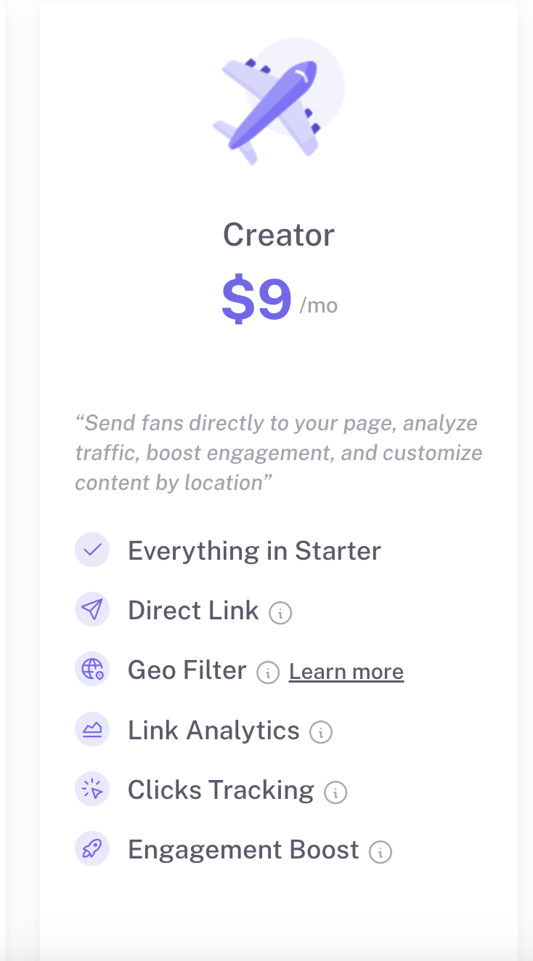

Additional Notes:

* Whatever other link page you are using, switch to Getallmylinks, it is currently by far the best option
  + It has link cloaking, which means when people click it, it will open up in their default browser, not the IG in-built browser. Many people will have already logged into OF in their default browser, thus making the funnel simpler for them, increasing conversions.
  + You can create a good looking link page that increases conversions
* **Create an Account on Carrd**
  + Visit [carrd.co](https://carrd.co).
  + Sign up for an account.
* Upgrade to **Premium** for just 4$/month to unlock all features.
* **Choose a Template**
  + Select this template: [**https://carrd.co/templates/a66ef184cb696120**](https://carrd.co/templates/a66ef184cb696120)
  + Click "Edit" or “Select” to start customizing the template.
  + Adjust the elements to fit your style while keeping the design clean and professional.
    - Update the colors to match your personal aesthetic.
    - Remove unnecessary sections and keep only four key sections:
  + Add your **Profile Picture** (high-quality, professional image).
  + Write a short **Bio** (you can use the same one as your Instagram profile).
  + Link **OF** directly to the **Button**.
  + Use the same **Call to Action** you see in the template.

*You can change the elements by clicking on them and then on the left side the dashboard will appear where you can edit according to your style.*

* Adding the page to your Getallmylinks

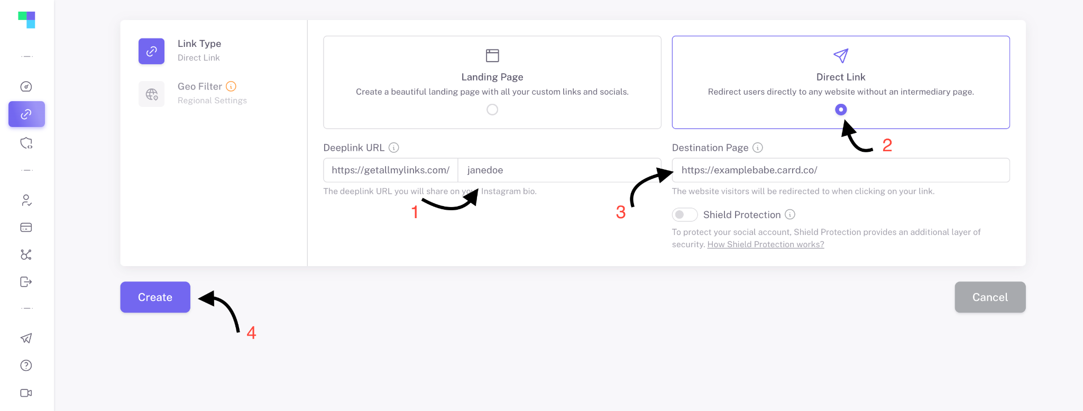

1. Add Links username, use the same you have on ig
2. Click on “Direct Link”
3. Add your landing page you created on cardd.co
4. Create the link!
   * Additionally, for creators in the Advanced team, once we add it to our Agency Getallmylinks page, we can provide an additional cloaking function that improves the funnel further.
     + In the beginning don’t worry about this function. As long as you get views, your funnel will already be highly performing.

* **Step 2 - Seting up your Instagram account**
* Putting in the link in bio
  + Go to your Instagram Profile
  + Click “Edit Profile”
  + Delete any old link you might have in there
  + Add the new link, that will look like “[Getallmylinks.com/xyz](http://getallmylinks.com/xyz)”
    - Don’t add any Title or picture, if given the option
* Picture + Bio
  + Add a profile picture that is a portrait.
    - As a general rule: colors and smiles will be attractive
  + Add a short, but simple bio that describes you. Example can be:
    - Tattooed Princess
    - Not a regular country girl
    - Fit and tanned
  + These are just examples, find something that describes you and include a keyword that describes you, like here: Tattoo, Country, Tan, Fit etc…
* Story Highlights
  + Set up several story highlights to organize you stories into
    - If you have no organized highlights, you want to get 30 different stories highlighted as soon as possible to show activity
    - If you have an older account, you might actually want to sort out old stories.
    - Generally you want to add and clean over time, the sweet spot being somewhere between 100-200 interesting stories in highlights.
    - One of the highlights should be where you always add a few promotional stories, with a spicy emoji as the name, or similar.
      * This way there’s another place for people to click the link and funnel to Getallmylinks.
* Messages
  + General guideline: Do not answer messages from random people on IG. These can be subscribers, who are being handled on OF, and if you start talking with them on IG, they will try to move out of OF and start buying.
    - Never chat with subscriber outside of Onlyfans, you will massively hurt the sales process
    - And you might get messages like “You didn’t answer me on OF” or any other random request.
      * All of these people are being categorized and handled appropriately, they will just look for a million ways to get out of OF and spend money to talk to you.
      * Ignore them and and the funnel will work great
* **Step 3 - Setting up Onlyfans**
* **Part 1: Profile Page Settings**
  + Go to Settings, then “Profile”
  + Set a profile picture that is a closeup of you. In a bikini or a bra, wearing a push up, make your boobs look big.
  + Set a banner picture of you in a bikini or lingerie, show off your body
    - When you put the picture in, check how it looks on your phone!
    - You will likely do the adjustments on your computer, but 95% of your traffic will come on the phone.
    - The banner might look “wrong” on the computer, but that doesn’t matter as long as it looks right on the phone.
  + Add a bio
    - This should be simple, but playful. 1-3 sentences only, don’t make it super long
    - Make it related to your brand and in a way that leads people to think they could see more on OF
      * Examples:
      * If your IG is lots in bikinis - “You’ve seen me in a bikini, here you’ll get to see me without one🙈”
      * If you have lots of tattoos - “Come and check out the tattoos that I can’t show you on other pages😈”
      * Or any other idea that relates to your brand.
  + Don’t add any location, wishlist, other website etc…
    - Do not introduce complexity into the funnel or other places for people to end up in. It should be a straight line to your messages where sales can work with people.
    - Any additional link or button will only hurt your conversions, thus your earnings in the long term.
* **Part 2: Subscription Price and Promotions**
  + Go to “Subscription Price and Bundles” in Settings
  + Set your subscription price to 15$ monthly.
  + Set up a Promotion campaign for New Subscribers
    - Add 80% First month discount
    - Select 50 Subscribers
    - Write in this text or similar, clear version in description: “80% OFF for the next 50 subscribers!!!”
  + Set up a Promotion campaign for Expired Subscribers
    - Add 80% First Month Discount
    - Select 20 Subscribers
    - Write in this text or similar, clear version in description: “POSTED MY SEXIEST CONTENT YET, COME CHECK OUT THE FEED AGAIN!”
  + You are done with pricing and promotions.
    - Do not set up any subscription bundles, trial links or similiar.
  + Make sure to reset and set up these promotions again when are are close to running out. Always the same text and same settings.
    - For Advanced Team creators, we have an automation to set up and renew promotions, the Sales team takes care of setting up slightly different promotions.
* **Part 3: Other Settings**
  + Go to Settings
  + Go to “Privacy and Safety”
    - Set up all the settings exactly as shown here:

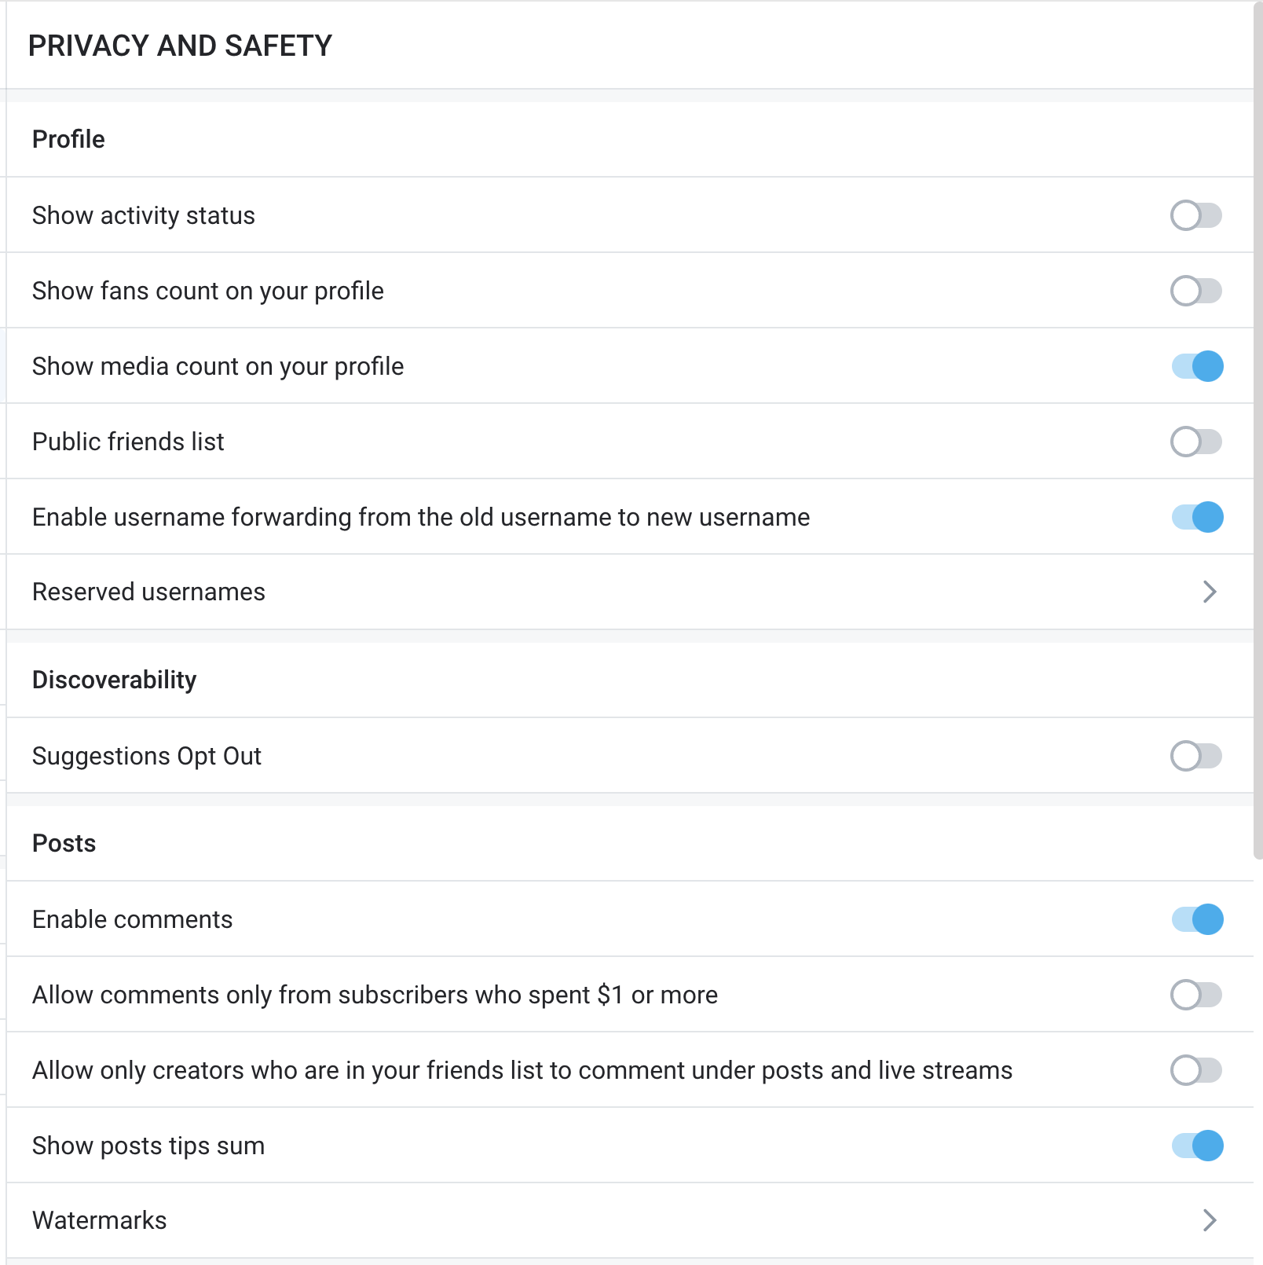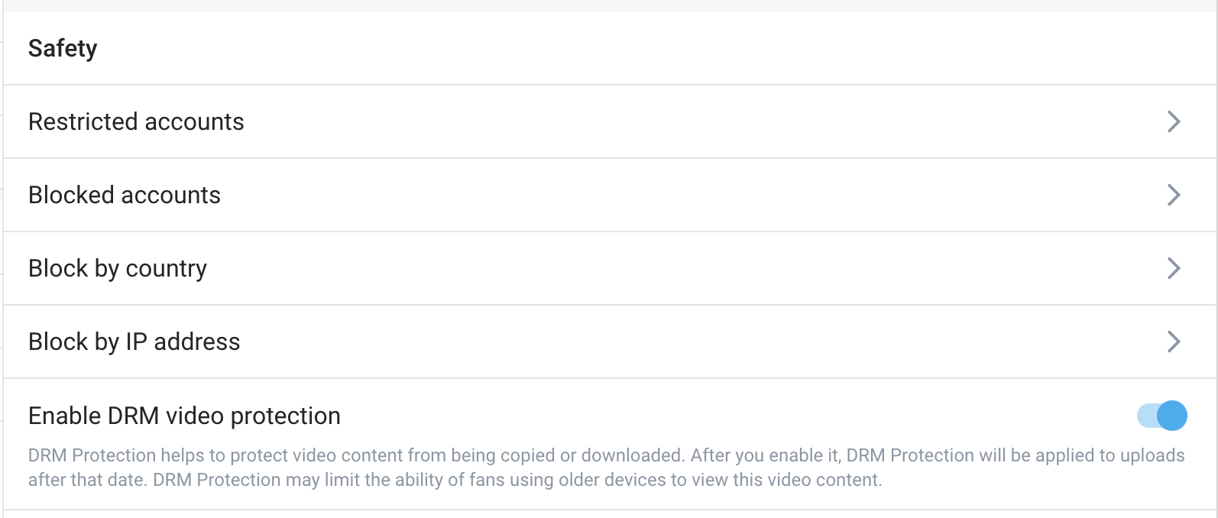

* Generally, we suggest not blocking any countries.
  + If you’re in the business, be in it.
  + For example, if you are living in France, you will get a lot of your traffic from France at first. If it is blocked, you’ll be killing your own conversions and setting yourself up for a much slower start.
  + Our target audience are English speaking people, particularly from the UK, USA and Canada. You will grow this audience in time, as you put out content in English, but that will take time.
  + If you want to block a country, talk it over with the team on a call, so we understand your situation better.
* Go to “Fans and Following”
  + Set up all the settings exactly as shown here

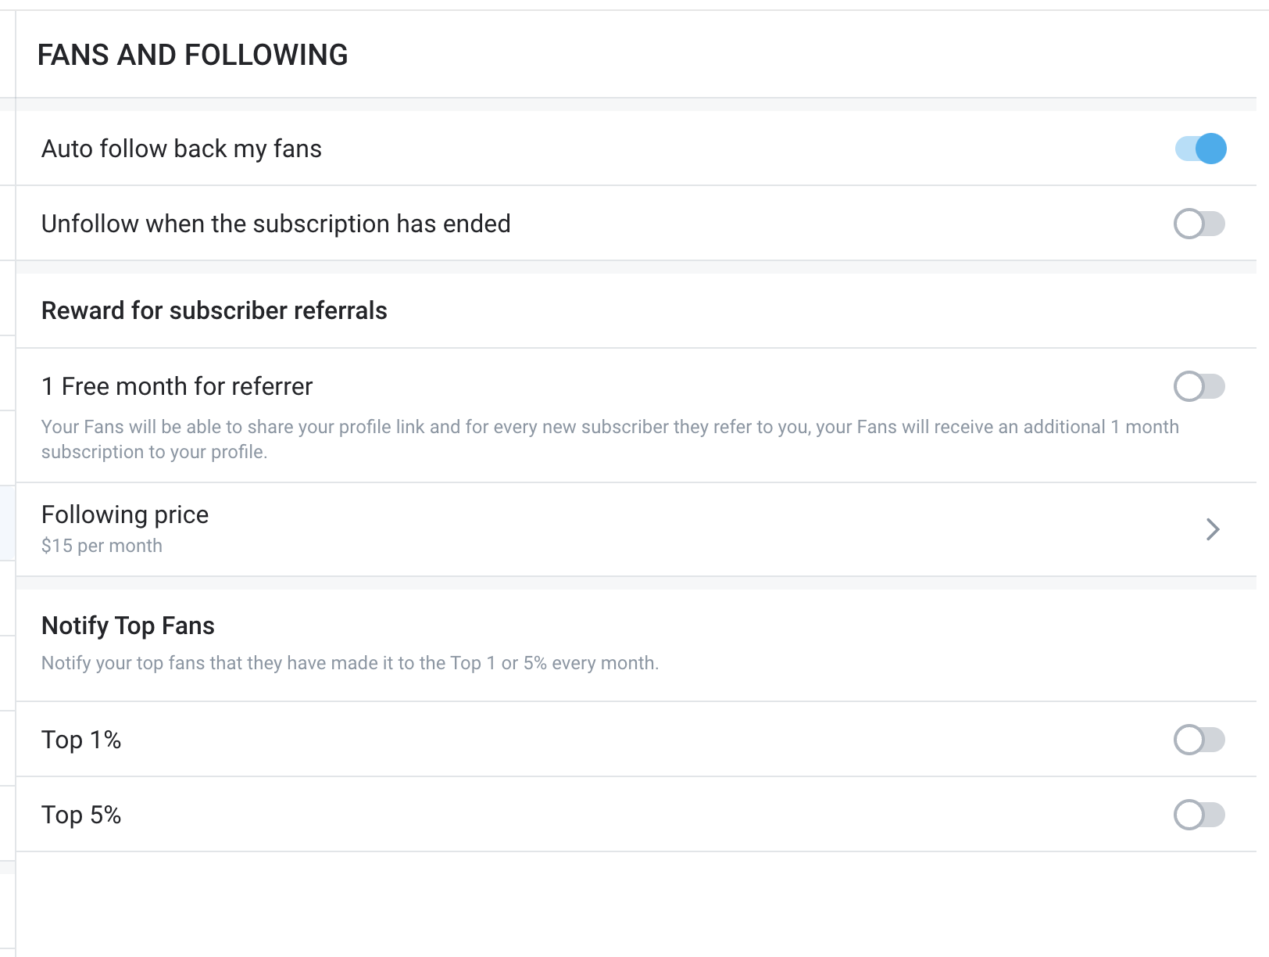

* Go to “Notifications”
  + Here, we suggest turning off all Email notifications.
    - It’s all the same things that will already show up on the OF page, this will just spam your email unnecessarily.
    - None of these will gie any important information, just give you notification overload.
* Go to “Chats”
  + Turn on “Send a welcome message to new Fans”
  + Here’s an example message to set up. Rewrite this in a similar manner, main points being:
    - Add 3-5 sexy lingerie picture here. Don’t put anything hardcore, we want to preserve your value.
    - Say hi to new subscribers
    - Give them a task to like all your posts for an extra surprise
    - Tell them you can’t wait to chat with them
    - Example:
      * Hi! I’m *NAME*. Welcome to my page! I’m so happy to have you here! 💕

Want to have something extra? if you like all my posts, I’ll send you a surprise! 🎁✨ And tell me more about yourself, what’s your name, where you’re from, and where did you find me?👀

I’ll love to chat on there, so I’ll send you a message when I’m online! Happy to see you here and let’s get to know each other! 😘💬

* The first goal is to get them to like all your posts, as the like amount shows up on your profile page, people decide to subscribe or not based on the likes amount. You need to get this engagement, it will boost your conversion rate
* Second, to make sure they know chats is the place to be and they should engage in chats, they’ll be able to get more there.
* **Part 4: Feed**
  + First thing, if you have an existing page and any hardcore content on your feed, all those posts take off the feed by clicking “Add to private archive”
  + If you do not have yet, get 30 posts on your feed.
    - You can post those 30 posts even across 3 days, for example, to get content on there rapidly
    - Can be both sexy and casual picture of you here, just get content on there.
  + From there do a feed post every 2 days
    - These should be sexy pictures, but nothing hardcore. Keep the best content for chats. Imagine IG, but sexier.
    - You want just enough for people to resubscribe, but not enough where there is nothing better to sell on chats.
  + Make one really great post, that’s really sexy and add a caption to it, telling people that you welcome them to your page and you can’t wait to to chat with them in DMs. Pin this post to the top of your feed.
    - This is a key continuation of the funnel, so people get more triggers to go to chats.
  + For Advanced team creators, all steps here are handled by the Sales team.
* This is the end of the funnel. If everything in your TikTok, Instagram, Getallmylinks and Onlyfans is set up properly, people should funnel very cleanly to chats and give you a good conversion rate and sales ratio over time.

## Frequently Asked Questions

* **I’ve seen others add more links or wishlists, shouldn’t we?**
  + Absolutely not. That’s one of the main reasons where people lose massive amounts of conversion.
  + And even because you might see a successful creator have it set up differently, doesn’t mean they don’t lose a massive amount of conversions also. They might be having even higher conversions with a simpler setup.
    - Or consider that the system behind their accounts might be significantly different in the backend, and you don’t know the rationale behind it. If you just take one piece of their system, without knowing the rest of it, doesn’t mean it will work for you.
  + Generally people love to overcomplicate things. Simplicity is key. Making sure people have a very straight line to subscriptions and chats is key. And whenever they look somewhere else, they get directed in the right direction again.
    - Imagine it like a highway. You’re going from city A to city B.
      * If this highway has no other exits, then there is a very high chance all the traffic will end up in city B, right?
      * But if there are 2 other exits on the highway, some of the traffic will end up somewhere else.
      * And if there are 5 other exits on the highway, then even more of the traffic will end up in other places.
      * You want all of it to end up in city B!
  + It’s simple and that’s exactly why it works great!
* **Why is the subscription price so low?**
  + The goal of the funnel is two fold:
    - Get as many people into your account as possible
    - Filter out the ones who aren’t willing to spend even a couple of dollars
  + You don’t know which one of your subscribers will become a big spender and which ones will be time wasters
    - As long as they have a card connected to OF and can spend a few dollars for subscribing, they might spend money.
    - Our sales team is really good at finding big spenders, filtering the traffic that comes through.
  + Think of it a bit like lottery tickets.
    - You never know which lottery ticket will be the winner.
    - But if you happen to get 100 lottery tickets, you are much more likely to win something than if you had 10 lottery tickets.
    - And in this case, the people are paying you to be your lottery tickets, it’s even better!
  + Simply put, the more paying subscribers we can get through the funnel, the more money will be generated.
  + Additionally, having such a high discount is an important psychological tactic. When people see a large discount, they feel lucky and are more likely to make a purchase.
    - People are simple, if they see a large discount, they want to buy.
  + After the first month, a lot of people will churn and that’s fine. The timewasters go away and the spenders stay because of the relationship building done by the Sales team.